**Blinkit Analysis**

* See All the data imported in SQL:
  + **Select * from blinkit_data**
* **Data Cleaning:**

Cleaning the Item Fat Content field ensures data consistency and accuracy in analysis. The presence of multiple variations of the same category (e.g., LF, low fat vs. Low Fat) can cause issues in reporting, aggregations, and filtering. By standardizing these values, we improve data quality, making it easier to generate insights and maintain uniformity in our datasets.

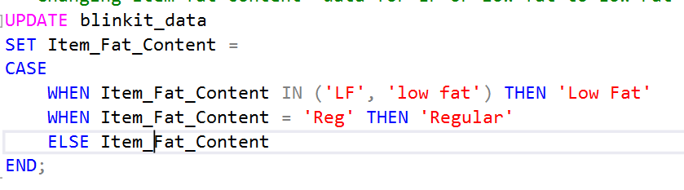

After executing this query check the data has been cleaned or not using below query



Result:

1. **KPIS**
2. **Total Sales**

* **Total Sales of Regular Fat:**

* **Total Sales of Low Fat**
* A screenshot of a computer

  AI-generated content may be incorrect.

1. **Average Sales**

* **Average Sales for Outlet Establishment Year 2022**

1. **No. Of Items**

* **No of Canned Items Sold**

1. **Average Rating**

* **Average Rating Per Item Type**
* **A screenshot of a computer

  AI-generated content may be incorrect.**
* **- General Requirements**
* **1. Total Sales, Average Sales, No of Items sold & Average Rating by Item Fat Content**
* **A screenshot of a computer

  AI-generated content may be incorrect.**

**2. Total Sales, Average Sales, No of Items sold & Average Rating by Item Type**

**3. Fat Content by Outlet For Total Sales, Average Sales, No of Items sold & Average Rating**

**Using Pivot to calculate Total Sales for Outlet type by Fat Content:**

**4. Total Sales, Average Sales, No of Items sold & Average Rating by Outlet Establishment**

1. **Percentage of Sales by Outlet Size**

**Query Explanation:**

Outlet Size: This column represents the size category of the outlet (e.g., Small, Medium,

Large).

**CAST(SUM(Total Sales) AS DECIMAL(10,2)) AS Total Sales:**

* . SUM(Total Sales): Calculates the total sales for each Outlet Size.
* . CAST( ... AS DECIMAL(10,2)): Formats the resulting sum to a decimal number with two

decimal places for precision.

**CAST((SUM(Total Sales) * 100.0 / SUM(SUM(Total Sales)) OVER()) AS DECIMAL(10,2)) AS**

**Sales Percentage:**

. **SUM(Total Sales) * 100.0:** Multiplies the total sales of the current Outlet Size by

100 to prepare for percentage calculation.

. **SUM(SUM(Total Sales)) OVER():**

* **SUM(Total Sales)**: Within the GROUP BY context, this computes the total sales

for each Outlet Size.

* **SUM( ... ) OVER():** The outer SUM combined with the OVER() clause calculates

the grand total of all Total Sales across all outlet sizes without collapsing the result set.

* **SUM(Total Sales) * 100.0 / SUM(SUM(Total Sales)) OVER():** Divides the total sales of

the current Outlet Size by the grand total sales and multiplies by 100 to get the

percentage contribution of each outlet size to the overall sales.

* **CAST( ... AS DECIMAL(10,2)):** Formats the resulting percentage to two decimal places.

1. **Total Sales, Average Sales, Percentage Sales, No of Items sold & Average Rating By Outlet Location**

1. **Total Sales, Average Sales, Percentage Sales, No of Items sold & Average Rating By Outlet Type for year 2020.**

